### Telomeres reveal silver spoon effects in a wild population

Lewis G. Spurgina,b, Kat Bebbingtona, Eleanor A. Fairfielda, Jan Komdeurc, Terry Burked, Hannah, L. Dugdalec,d, and David S. Richardsona,e,.

1. School of Biological Sciences, University of East Anglia, Norwich Research Park, NR4 7TJ, United Kingdom
2. Department of Zoology, Edward Grey Institute, University of Oxford, Oxford, UK
3. Groningen Institute for Evolutionary Life Sciences, University of Groningen, Groningen, The Netherlands
4. Department of Animal and Plant Sciences, University of Sheffield, Sheffield, UK
5. Nature Seychelles, Roche Caiman, Mahé, Republic of Seychelles

**Correspondence:** Lewis Spurgin: [lewisspurgin@gmail.com](mailto:lewisspurgin@gmail.com); David Richardson: [david.richardson@uea.ac.uk](mailto:david.richardson@uea.ac.uk)

### Abstract

Understanding the links between early-life experiences and later-life survival is fundamental to understanding life-history evolution. Telomeres – the protective caps at the ends of chromosomes – shorten in response to early-life stress, and telomere shortening in early life is correlated with reduced later-life survival. As telomeres are a biomarker of the impact of early-life stress, they may provide a link between early-life environmental variation and later-life fitness. We tested whether telomere dynamics link spatiotemporal variation in early-life conditions to survival using a long-term study of the Seychelles warbler (*Acrocephalus sechellensis*). We show that early-life telomere dynamics vary markedly across cohorts, and that individuals born in breeding seasons with higher food availability had longer telomeres and reduced telomere shortening. Within cohorts, we found that telomere length in nestlings was negatively related to tarsus length (which probably represents nestling growth), and positively related to the number of helpers present in the natal territory. Finally, we found that increased survival later in life was associated with longer telomeres and reduced telomere shortening rates in early life. Our results indicate that telomeres may provide a link between early-life conditions and late-life survival in wild populations.

**Keywords:** Life-history; Seychelles warbler; Senescence; Survival; Telomeres

### Introduction

Favourable environmental conditions during development and growth can confer fitness advantages later in life (so called 'silver spoon effects') (Grafen 1988; Monaghan 2008). Adult fitness can be affected by a range of early-life experiences, including the quality of the habitat and available resources (Madsen and Shine 2000; Van de Pol et al. 2006; Hayward et al. 2013), population density (Nussey et al. 2007; Douhard et al. 2013) and natural or anthropogenic environmental disturbance (Reid et al. 2003; Cartwright et al. 2014). Understanding the causes and consequences of these early-life experiences is key to understanding many ecological and evolutionary processes, including patterns of natural and sexual selection, population growth rates and even local extinction (Coulson et al. 2001; Roach and Carey 2014). Understanding silver spoon effects is therefore of central interest to ecologists, evolutionary biologists and conservationists.

While it is clear that silver spoon effects can occur, we have little understanding of how and under what conditions early-life environments will affect adult fitness. However, we do expect the later-life consequences of a good or poor start to vary among individuals, populations and species because the phenotypic consequences of an adverse environment can depend on an individual's initial condition, and genetic or epigenetic makeup (Hoffman and Hercus 2000; Richards 2006). Moreover, it is not always possible to fully quantify what constitutes a good or bad environment, and any 'hidden' environmental variation may obscure relationships between the early-life conditions that are measured and the resulting adult phenotypes. Indeed, the pervasiveness of silver spoon effects varies between species (Drummond et al. 2011), cohorts (Reid et al. 2003) and sexes (Wilkin and Sheldon 2009). We therefore need to understand, or at least be able to measure, how the environment affects individuals differentially within a population in order to elucidate the later-life consequences of early-life experiences.

A key process that has been associated with adult survival is the rate at which telomeres are shortened. Telomeres are protective caps on the ends of chromosomes that shorten with age (Monaghan and Haussmann 2006), and in response to oxidative stress, which can be elevated by environmental factors (Von Zglinicki 2002). When telomeres become critically short cells senesce (Campisi 2003), and the accumulation of these cells can result in organismal senescence and death (Wong et al. 2003). This association between senescence and telomere length has inspired a great deal of recent research into telomere ecology (reviewed in Horn et al. 2010; Haussmann and Marchetto 2010; Monaghan 2014). While there is little direct evidence that the relationship between telomere dynamics and survival is causal (Barrett and Richardson 2011; Simons 2015), there is now excellent evidence that telomeres can act as biomarkers of cost in wild populations, providing a signature of the ecological stress that has been experienced that is otherwise difficult to detect (Monaghan 2014; Schultner et al. 2014; Asghar et al. 2015).

There is evidence from a range of taxa that the greatest rate of telomere loss occurs in early life (e.g. Frenck et al. 1998; Haussmann et al. 2003), and that the extent of this telomere shortening is influenced by the conditions experienced during that period (Price et al. 2013; Monaghan 2014; Nettle et al. 2015b; Reichert et al. 2015). Importantly, early-life telomere dynamics are associated with both short-term and late-life survival (Heidinger et al. 2012; Boonekamp et al. 2014), and with other parameters such as cognition (Nettle et al. 2015a). However, the link between late-life survival and early-life conditions has only been demonstrated in a few species, and thus is poorly understood. Moreover, how early-life telomere dynamics vary over spatial and temporal scales is not known.

The longitudinal study (since 1986) of the Seychelles warbler (*Acrocephalus sechellensis*) population on Cousin Island provides an excellent model system for studying senescence in the wild (reviewed in Hammers et al. 2015). Due to the isolated nature of the study population and intensive field monitoring, we have unusually comprehensive survival data and tissue samples spanning many years (see Methods, below). Ecological conditions and warbler population density on Cousin vary across space and time due to weather-induced changes in foliage cover and food availability (Van de Crommenacker et al. 2011). Seychelles warblers remain on their natal territories for at least six months, and variation in the oxidative stress experienced by individuals is associated with natal territory quality (Van de Crommenacker et al. 2011). However, neither early-life nor adult survival appear to be associated with natal territory quality or natal local density (Brouwer et al. 2006; Hammers et al. 2013). Facultative cooperative breeding occurs in the Seychelles warbler (Komdeur 1994b; Richardson et al. 2003b), and the presence of helping subordinates (but not non-helping subordinates) in the natal territory has been found to be associated with increased survival later in life (Brouwer et al. 2012). Lastly, we have an established protocol for assessing absolute telomere length in this species (Barrett et al. 2012), and telomere length predicts survival independently of age in adult Seychelles warblers, suggesting that telomeres act as a biomarker of cost (Barrett et al. 2013). Thus, we have an excellent system in which to assess the costs of different social and environmental conditions experienced early in life, and to assess the later-life consequences of early-life conditions.

In this study we test the prediction that telomeres link early-life environmental variation to late-life fitness. Because telomere dynamics are expected to reflect individual-level variation in the costs of early-life experiences, they may allow a more sensitive analysis of the effects of early-life environmental variation than would be possible with a direct comparison of how survival is affected by the early-life environment. With this in mind, we predict that: (i) individuals raised in higher-quality conditions will subsequently? have longer telomeres, and (ii) having longer telomeres in early life is associated with greater survival.

### Methods

##### Study species and sampling

The Seychelles warbler is a small (~15 g), insectivorous passerine bird with a mean life expectancy of 5.5 years at fledging (Hammers et al. 2013). The population of *ca* 320 birds on Cousin Island (04'20'S, 55'40'E) has been intensively studied since 1986 (Richardson et al. 2003a; Spurgin et al. 2014). This species has two breeding seasons, running from June–August (main breeding season) and December–February (minor breeding season), when the breeding females on each of the *ca* 115 territories lay one or, rarely, two or three eggs (Komdeur et al. 1991). As a result of this low reproductive output, combined with higher mortality in first-year birds (39%; Brouwer et al. 2006), cohort sizes in the Seychelles warbler are small (<50).

Individuals are usually ringed in their first year of life, and so are of known age. They are then followed throughout their lives, and as they are non-migratory endemics naturally confined to the island (Komdeur et al. 2004), a biannual census of birds on Cousin during each breeding season gives accurate measures of local density and individual survival (Barrett et al. 2013). The isolated nature of the Cousin population is a key advantage of the system for analyses involving survival, which in other systems are often confounded by emigration (see Ergon and Gardner 2014 for a recent discussion). Full details of catching and monitoring methods can be found in Brouwer *et al.* (2012).

Seychelles warblers are highly territorial and all territories are mapped during the breeding seasons using detailed observational data of foraging and territorial defence behaviour, and surveyed for territory quality (Richardson et al. 2003a). Territory quality is calculated based on territory size, foliage cover and insect abundance (Komdeur 1992), and territory quality estimates obtained across years are averaged to obtain a single value for each territory (Hammers et al. 2013). Cousin is subject to intra- and inter-annual variation in rainfall and food availability, and such island-wide temporal variation may override the effects of individual territory quality. As an estimate of seasonal variation in food availability, we calculated an index of the number of insects across the entire island during each breeding season. This index represents the average number of insects found per unit leaf area over all surveys carried out on the island in a breeding season.

Each time a bird is caught on Cousin, body mass and tarsus length are measured (to the nearest 0.1g and 0.1mm, respectively), and age is confirmed on the basis of eye colour (Komdeur 1991) and previous captures (Richardson et al. 2003a). A blood sample (*ca* 25 $μ$ l) is taken from each captured bird via brachial venipuncture, and stored at room temperature in 1 ml of absolute ethanol in a 1.5-ml screw-cap microfuge tube.

##### Molecular methods

Genomic DNA was extracted from a ~2 mm2 flake of preserved blood using the DNeasy Blood and Tissue Kit (Qiagen), following the manufacturer's protocol, with the modification of overnight lysis at 37°C and a final DNA elution volume of 80 $μ$ l. DNA concentration and purity were quantified using a NanoDrop 8000 Spectrophotometer (ThermoScientific), and DNA integrity was validated by visualization with ethidium bromide after electrophoresis on a 1.2% agarose gel. Sex was determined using the molecular method outlined by Griffiths *et al.* (1998).

Telomere lengths were measured in 406 samples. Of these, 323 were taken cross-sectionally from birds caught within their first year of life, between 1995 and 2009; 80 were nestlings less than one month old (chicks), while the remaining 243 were fledglings and subadults aged between two and twelve months (hereafter referred to as fledglings). For a subset of first-year birds (n = 83 individuals) we had longitudinal data, with an additional sample taken within two years of the original catch. We measured absolute telomere quantity per diploid genome for all samples using a quantitative PCR (qPCR) assay (full details in Barrett et al. 2012).

##### Statistical analyses

We performed all analyses using R version 3.0.1 (R Development Core Team 2011). Our sampling regime covers 14 years, and temporal variation in rainfall and food availability on Cousin Island over this period is expected to result in variation in a range of social and environmental variables (Brouwer et al. 2012). This makes it difficult to disentangle how spatial and temporal processes differentially affect early-life telomere dynamics. To overcome this, we analysed how variation in early-life telomere length was related to variation in early-life conditions both among and within breeding seasons.

First, to analyse whether temporal variation in food availability drives population-level variation in telomere dynamics, we calculated mean telomere length among all birds born in a given (major or minor) breeding season (i.e. a cohort), excluding cohorts where the sample size $≤$ 5 birds (n = 17 cohorts). We tested for a difference in telomere length among cohorts using a one-way ANOVA, and then used linear regression to test whether variation in mean telomere length among cohorts is explained by temporal variation in insect abundance.

We then conducted individual-level analyses to test how spatial variation in early-life environmental and social conditions influenced telomere length within cohorts, using general linear models. For these analyses, both response and explanatory variables were standardised by mean-centring within cohorts, thus controlling for any between-cohort temporal variation in telomere length and the social and ecological environment. As explanatory variables we included age class (nestling or fledgling), tarsus length, sex, territory quality and the number of helping and non-helping subordinate birds present in the natal territory. We also included interactions between age class and all the other variables. We used model averaging to assess how these variables shape telomere length and dynamics in early life. We created a full model containing all of the above terms, and a top model set was then defined, containing all models with AICc $≤$ 6 compared to the best supported model (Burnham et al. 2011). We report model-averaged coefficients, confidence intervals and 'relative importance', which reflects the relative weights of each predictor variable across the top model set. Model averaging was carried out using the MuMIn package (version 1.10.5) in R (Bartoń 2012).

For individuals with longitudinal data (*n* = 83) we calculated a rate of telomere loss between the first-year sample and earliest adult sample by subtracting the adult telomere length from the early-life telomere length and dividing this difference by the length of time (in days) between sampling events. To account for regression to the mean effects, we applied a correction based on correlations among samples within individuals following Verhulst *et al.* (2013). Using this dataset we repeated the above analyses of among and within cohort telomere dynamics, replacing telomere length with telomere loss as the response variable.

Finally, we analysed the effects of telomere dynamics on survival, again by looking at variation both within and among cohorts. First, we tested the prediction that cohort-level telomere dynamics are associated with survival by comparing the mean lifespan of all individuals within each cohort with mean telomere length and rate of loss in that cohort, using linear regression. We then used parametric survival analysis to test whether survival was related to individual-level telomere length and rate of loss. Again, we mean-centred variables within cohorts to eliminate between-season temporal variation in telomeres and survival. The survival time distribution was chosen by comparing the fit of the observed survival data against a range of distributions (exponential, Weibull, log-normal, gamma, Gompertz and generalized F) by visually inspecting plots and comparing AIC values. As explanatory variables of survival, we included early-life telomere length/loss (we ran a separate analysis for each, using the cross-sectional and longitudinal data, respectively), plus the factors identified as being related to telomere length in the previous analysis. With this approach we aimed to assess the relationship between early-life telomere length and survival, while controlling for potentially confounding variables that might be correlated with telomere dynamics.

### Results

##### Early-life telomere length and age

Mean ( $±$ standard error) telomere length in first-year birds was 5.15 $±$ 0.20 kb. This was lower than the mean for one-year-old birds based on cross-sectional data (5.46 $±$ 0.15 kb). However, when we considered age classes within the first year of life separately, we found substantial age-related variation in telomere length (F = 7.42; *P* = 0.007). Nestlings had longer telomeres than any other age group, but there was an apparent increase in mean? telomere length from the fledgling to adult stages (Fig. 1A). However, a longitudinal analysis of telomere loss showed that nestlings and fledglings both lost telomeric DNA early in life, and that there was no difference in the rate of telomere loss between the two age classes (F = 0.46; *P* = 0.50; Fig. 1B).

##### Temporal variation in early-life telomere dynamics

Early-life telomere length varied significantly among breeding seasons (one-way ANOVA, F = 2.13; *P* = 0.002), and this variation in mean? telomere length over breeding seasons was positively related to island-wide food availability (linear regression, R2 = 0.37; F = 6.91; *P* = 0.022; Fig. 2A). Running the regression of cohort-level telomere length and food availability separately for the two age classes revealed a positive, significant relationship in fledglings (R2 = 0.41; F = 6.82; *P* = 0.026), but no relationship in nestlings (R2 = 0.61; F = 3.09; *P* = 0.221), suggesting the selective disappearance of ????.

The rate of telomere shortening in early life (taken from the smaller subset of birds for which we had longitudinal samples) did not vary significantly among breeding seasons (F = 0.95; *P* = 0.53); however, what variation there was in rates of telomere shortening could be explained by temporal variation in food availability (R2 = 0.30; F = 5.14; *P* = 0.04). This pattern corresponded with the cross-sectional data: individuals born in seasons with low food availability lost telomeres, on average, at a faster rate than those born in years with high food availability (Fig. 2B). Unfortunately we did not have sufficient sample sizes within cohorts to run this analysis separately between age classes.

##### Spatial variation in early-life telomere dynamics

The top model explaining within-season variation in early-life telomere length contained age class, tarsus length and the number of helpers present in the natal territory, as well as interactions between age class and both tarsus length and the number of helpers (Table S1). This model was much better supported than the null model ($Δ$ AICc = 14.72). Both tarsus length and the number of helpers had high relative importance in the top model set (Fig. 3A), and the model containing these variables explained a reasonable amount of variation in telomere length (R2 = 0.11). Telomere length was positively related to the number of helpers in nestlings, but not in fledglings (Fig. 3B). Tarsus length was negatively related to telomere length in nestlings, but not in fledglings (Fig. 3C).

For the subset of individuals for which we had longitudinal data, we tested whether the factors previously identified as being related to early-life telomere length (i.e. tarsus length and number of helpers) were also associated with differences in rates of early-life telomere loss. Due to the limited sample size, we considered all age classes together for this analysis. We found that none of these variables were associated with differences in telomere loss (all *P* > 0.05).

##### Early-life telomere dynamics and survival

At the population-level, there was no relationship between lifespan and telomere length (R2 = 0.079; F = 1.28; *P* = 0.28; Fig. 4A). Testing this relationship separately for each age class revealed that there was no age-specific relationship between lifespan and cohort-level telomere length (both *P* > 0.2). There was a negative relationship between lifespan and population-level telomere loss, although this was marginally non-significant (R2 = 0.202; F = 3.80; *P* = 0.07; Fig. 4B).

For the individual-based survival analysis, a log-normal survival model best fitted the Seychelles warbler data (AIC = 1108.59, AIC of next best distribution (Weibull) = 1127.05). A survival model including all first-year birds showed that early-life telomere length had a positive effect on survival, but this relationship was marginally non-significant (estimate = 0.056, CI = -0.072–0.184). Running this analysis between age classes revealed differential survival effects. Nestling telomere length had no effect on survival (estimate = -0.128, CI = -0.344–0.089; Fig. 5A), but telomere length at the fledgling stage was significantly related to survival (estimate = 0.247, CI = 0.105–0.389). This effect was positive, with increased survival later in life associated with longer telomeres at the fledgling stage (Fig. 6B). Finally, using the longitudinal data, we found no effect of early-life telomere shortening on subsequent survival (estimate = 0.16, CI = -0.088–0.401).

### Discussion

Here we show that telomeres link early-life conditions to later-life survival in the Seychelles warbler. We first show that telomere length and rates of shortening in early life are subject to strong cohort effects, and that cohort-level telomere dynamics can be explained by island-wide temporal variation in food availability. We then show that within cohorts, the social environment (i.e. number of helpers) affects telomere length specifically at the nestling stage. Finally, we show that telomere length in early life predicts later-life survival. These findings have important implications for research on life-history evolution in wild populations.

Our finding that early-life telomere length and rate of shortening are related to food availability adds to a growing body of evidence from humans and wild animals showing that the natal environment can have pronounced impacts on early-life telomere dynamics (reviewed in Price et al. 2013; Monaghan 2014). However, very few studies have shown that temporal variation in environmental conditions affects telomere dynamics in natural populations, and the studies that have done so were limited to just two seasons (Mizutani et al. 2013; Watson et al. 2015). The long-term Seychelles warbler dataset has allowed us, using many more cohorts than have been used in other studies, to show that temporal variation in environmental conditions does indeed affect telomere dynamics, and that this effect can be seen at the population level. Interestingly, in the Seychelles warbler, survival is not directly linked to annual variation in food availability (Brouwer et al. 2006; Hammers et al. 2013). It has been suggested that telomeres act as biomarkers of cost in natural populations, as they are able to capture individual and cohort-level variability in the costs experienced as a result of environmental pressures (Asghar et al. 2015). Our results confirm that telomeres can detect hidden costs in natural populations that are not detectable using life-history and environmental data alone.

We suspect that the novelty in our finding temporal, environmentally-induced variation in telomere dynamics within a population is more due to a lack of available long-term datasets with telomere screening, rather than the Seychelles warbler being unique. Indeed, the environment on Cousin is benign in comparison to many regions outside the tropics, where populations undergo large fluctuations in size (e.g. Coulson et al. 2001). If our findings are replicated in other systems, and population-level variation in early-life telomere dynamics is common in nature, this has a number of ramifications for our understanding of senescence in natural populations. First, our findings suggest that the telomere dynamics of a population at a given point in time represent a snapshot of a temporally varying process. More research is now needed within and across multiple cohorts and populations to better understand the complexity of telomere evolutionary ecology. Second, our findings raise the interesting prospect of using telomeres as indicators of population health – an approach that would be useful to a broad range of conservation and animal health practitioners. However, further research across populations with different environments and genetic histories is required in order to provide further insight into the usefulness of telomeres as biomarkers of population health.

We found that, within cohorts, tarsus length and the number of helpers were the most important predictors of telomere length in Seychelles warblers, and that these effects occurred specifically at the nestling stage. The tarsus effect probably reflects the fact that, in passerine birds, tarsus length is correlated with age during the nestling stage (Ricklefs 1976). Telomere loss is most rapid early in life due to ongoing cell replication (Frenck et al. 1998), and a negative correlation between telomere length and body size in early life is therefore expected.

Ours is the first study to show that the presence of helpers has a beneficial effect on offspring in terms of their telomeres. In the Seychelles warbler the survival benefits to a nestling of there being helpers in the natal territory is well established (Komdeur 1994a; Brouwer et al. 2012) and that the beneficial influence of helpers is detectable in terms of differential telomere length is therefore encouraging. However, we found no evidence that telomere loss was related to the number of helpers – this is perhaps surprising as telomere loss is expected to be a better indicator of stress than telomere length *per se* (Boonekamp et al. 2014). However, our longitudinal dataset was limited both in sample size and resolution (i.e. time between sampling events). Seychelles warblers are rarely sampled more than once? within their first year of life, so much of the telomere shortening that occurs in early life will be missed with our sampling regime. It is likely, therefore that only very strong effects of environmental variation on telomere loss will be detected in this dataset. Thus telomere length constitutes a better indicator of early-life stress.

While the relationship between mortality and telomeres in adults has been established for some time (Cawthon et al. 2003), only recently has the link between later-life survival and early-life telomere dynamics been studied. In captive zebra finches, juvenile telomere length predicts late-life survival (Heidinger et al. 2012) and, in wild bird populations, survival during the nestling phase (Watson et al. 2015) and survival to adulthood (Boonekamp et al. 2014) have been linked with early-life telomere dynamics. Our results are, to our knowledge, the first to demonstrate that later-life survival is associated with early-life telomere length in a wild population. This effect can be seen at the individual level, and (to a lesser extent) at the cohort level, although the nature of the relationship varies according to the age class in which telomeres are measured. At the individual level, we found that survival was related to telomere length in fledglings, but not nestlings. This is not surprising, as only by the fledgling stage is telomere length likely to reflect the accumulation of early-life stress (see also previous paragraph). The relationships between lifespan and population-level telomere length were in the expected direction (Fig. 4), but not significant, which is perhaps not surprising given that, even though we have a long-term dataset, we are still restricted in terms of sample size when conducting cohort-level analyses. Nonetheless, our data support the general conclusion that early-life telomere dynamics are important indicators of early-life stress.

There are numerous promising avenues for future research into telomere evolutionary ecology in this system and others. Here we have considered survival, but telomere length and shortening in early life may also be linked to other components of fitness (reviewed in Monaghan 2014). Reproductive senescence occurs in the Seychelles warbler (reviewed in Hammers et al. 2015), making this system well suited to examining how telomere length predicts? lifetime reproductive success. A further avenue for future research will be examining, in a quantitative genetic framework, how genetic and environmental components, and their interactions, affect telomere dynamics and senescence in natural populations (Asghar et al. 2014; Becker et al. 2015). We expect that by gaining a fuller understanding of telomere dynamics in natural populations, the fields of life-history evolution and evolutionary ecology will be greatly enhanced.

### Data accessibility

This manuscript was written in R Markdown (<http://rmarkdown.rstudio.com/>). All data and scripts required to reproduce the manuscript, figures and analyses will be made available on GitHub.

### Acknowledgements

We thank Nature Seychelles for facilitating the long-term Seychelles warbler project. The Seychelles Bureau of Standards and Department of Environment gave permission for the fieldwork, including blood? sampling. Emma Barrett laid the foundations for this study, generating much of the telomere data. We thank everyone who has helped in the field, and the current Seychelles warbler research group for useful discussions. This work was funded by two Natural Environment Research Council (NERC) grants to DSR (NE/F02083X/1 and NE/K005502/1). HLD was funded by a NERC fellowship.

### References

Asghar, M., S. Bensch, M. Tarka, B. Hansson, and D. Hasselquist. 2014. Maternal and genetic factors determine early life telomere length. Proceedings of the Royal Society B 282: 20142263–20142263.

Asghar, M., D. Hasselquist, B. Hansson, P. Zehtindjiev, H. Westerdahl, and S. Bensch. 2015. Hidden costs of infection: Chronic malaria accelerates telomere degradation and senescence in wild birds. Science 347:436–438.

Barrett, E. L. B., and D. S. Richardson. 2011. Sex differences in telomeres and lifespan. Aging Cell 10:913–21.

Barrett, E. L. B., W. Boner, E. Mulder, P. Monaghan, S. Verhulst, and D. S. Richardson. 2012. Absolute standards as a useful addition to the avian quantitative PCR telomere assay. Journal of Avian Biology 43:571–576.

Barrett, E. L. B., T. Burke, M. Hammers, J. Komdeur, and D. S. Richardson. 2013. Telomere length and dynamics predict mortality in a wild longitudinal study. Molecular Ecology 22:249–259.

Bartoń, K. 2012. Package ‘MuMIn’. Model selection and model averaging base on information criteria. R package version 1.7.11.

Becker, P. J. J., S. Reichert, S. Zahn, J. Hegelbach, S. Massemin, L. F. Keller, E. Postma, and F. Criscuolo. 2015. Mother–offspring and nest-mate resemblance but no heritability in early-life telomere length in white-throated dippers. Proceedings of the Royal Society B: 282:20142924.

Boonekamp, J. J., G. A. Mulder, H. M. Salomons, C. Dijkstra, and S. Verhulst. 2014. Nestling telomere shortening, but not telomere length, reflects developmental stress and predicts survival in wild birds. Proceedings of the Royal Society B: 281:20133287.

Brouwer, L., D. S. Richardson, C. Eikenaar, and J. Komdeur. 2006. The role of group size and environmental factors on survival in a cooperatively breeding tropical passerine. Journal of Animal Ecology 75:1321–1329.

Brouwer, L., D. Richardson, and J. Komdeur. 2012. Helpers at the nest improve late-life offspring performance: evidence from a long-term study and a cross-foster experiment. PLoS One 7:e33167.

Burnham, K., D. Anderson, and K. Huyvaert. 2011. AIC model selection and multimodel inference in behavioral ecology: some background, observations, and comparisons. Behavioral Ecology and Sociobiology 65:23–25.

Campisi, J. 2003. Cellular senescence and apoptosis: How cellular responses might influence aging phenotypes. Experimental Gerontology 38:5–11.

Cartwright, S. J., M. A. C. Nicoll, C. G. Jones, V. Tatayah, and K. Norris. 2014. Anthropogenic natal environmental effects on life histories in a wild bird population. Current Biology 24:536–40.

Cawthon, R. M., K. R. Smith, E. O’Brien, A. Sivatchenko, and R. A. Kerber. 2003. Association between telomere length in blood and mortality in people aged 60 years or older. Lancet 361:393–395.

Coulson, T., E. A. Catchpole, S. D. Albon, B. J. Morgan, J. M. Pemberton, T. H. Clutton-Brock, M. J. Crawley, and B. T. Grenfell. 2001. Age, sex, density, winter weather, and population crashes in Soay sheep. Science 292:1528–31.

Douhard, M., J.-M. Gaillard, D. Delorme, G. Capron, P. Duncan, F. Klein, and C. Bonenfant. 2013. Variation in adult body mass of roe deer: early environmental conditions influence early and late body growth of females. Ecology 94:1805–1814.

Drummond, H., C. Rodríguez, and D. Oro. 2011. Natural ’poor start’ does not increase mortality over the lifetime. Proceedings of the Royal Society B: 278: 3421–3427.

Ergon, T., and B. Gardner. 2014. Separating mortality and emigration: modelling space use, dispersal and survival with robust-design spatial capture-recapture data. Methods in Ecology and Evolution 5:1327–1336.

Frenck, R. W., E. H. Blackburn, and K. M. Shannon. 1998. The rate of telomere sequence loss in human leukocytes varies with age. Proceedings of the National Academy of Sciences of the United States of America 95:5607–5610.

Grafen, A. 1988. On the uses of data on lifetime reproductive success. *in* T. Clutton-Brock, ed. Reproductive Success. ++++

Griffiths, R., M. C. Double, K. Orr, and R. J. Dawson. 1998. A DNA test to sex most birds. Molecular Ecology 7:1071–5.

Hammers, M., S. A. Kingma, K. Bebbington, J. Van de Crommenacker, L. G. Spurgin, D. S. Richardson, T. Burke, H. L. Dugdale, and J. Komdeur. 2015. Senescence in the wild: Insights from a long-term study on Seychelles warblers. Experimental Gerontology, doi: [10.1016/j.exger.2015.08.019](http://dx.doi.org/10.1016/j.exger.2015.08.019).

Hammers, M., D. S. Richardson, T. Burke, and J. Komdeur. 2013. The impact of reproductive investment and early-life environmental conditions on senescence: support for the disposable soma hypothesis. Journal of Evolutionary Biology 26:1999–2007.

Haussmann, M. F., and N. M. Marchetto. 2010. Telomeres: Linking stress and survival, ecology and evolution. Current Zoology 56:714–727.

Haussmann, M. F., C. M. Vleck, and I. C. T. Nisbet. 2003. Calibrating the telomere clock in common terns, *Sterna hirundo*. Experimental Gerontology 38:787–789.

Hayward, A. D., I. J. Rickard, and V. Lummaa. 2013. Influence of early-life nutrition on mortality and reproductive success during a subsequent famine in a preindustrial population. Proceedings of the National Academy of Sciences of the United States of America 110:13886–91.

Heidinger, B. J., J. D. Blount, W. Boner, K. Griffiths, N. B. Metcalfe, and P. Monaghan. 2012. Telomere length in early life predicts lifespan. Proceedings of the National Academy of Sciences of the United States of America 109:1743–8.

Hoffman, A. A., and M. J. Hercus. 2000. Environmental Stress as an Evolutionary Force. BioScience 50:217–226. Oxford University Press.

Horn, T., B. C. Robertson, and N. J. Gemmell. 2010. The use of telomere length in ecology and evolutionary biology. Heredity 105:497–506.

Komdeur, J. 1991. Cooperative breeding in the Seychelles warbler. PhD Thesis, Cambridge University.

Komdeur, J. 1994a. Experimental evidence for helping and hindering by previous offspring in the cooperative-breeding Seychelles warbler *Acrocephalus sechellensis*.

Komdeur, J. 1992. Importance of habitat saturation and territory quality for evolution of cooperative breeding in the Seychelles warbler. Nature 358:493–495.

Komdeur, J. 1994b. The effect of kinship on helping in the cooperative breeding Seychelles warbler (*Acrocephalus sechellensis*).

Komdeur, J., I. D. Bullock, and M. R. W. Rands. 1991. Conserving the Seychelles Warbler Acrocephalus sechellensis by translocation: a transfer from Cousin Island to Aride Island.

Komdeur, J., T. Piersma, K. Kraaijeveld, F. Kraaijeveld-Smit, and D. S. Richardson. 2004. Why Seychelles Warblers fail to recolonize nearby islands: Unwilling or unable to fly there? Ibis 146:298–302.

Madsen, T., and R. Shine. 2000. Silver spoons and snake body sizes: prey availability early in life influences long‐term growth rates of free‐ranging pythons. Journal of Animal Ecology 69:952–958.

Mizutani, Y., N. Tomita, Y. Niizuma, and K. Yoda. 2013. Environmental perturbations influence telomere dynamics in long-lived birds in their natural habitat. Biology Letters 9:20130511.

Monaghan, P. 2008. Early growth conditions, phenotypic development and environmental change. Philosophical Transactions of the Royal Society B: 363:1365.

Monaghan, P. 2014. Organismal stress, telomeres and life histories. Journal of Experimental Biology 217:57–66.

Monaghan, P., and M. F. Haussmann. 2006. Do telomere dynamics link lifestyle and lifespan? Trends in Ecology and Evolution 21:47–53.

Nettle, D., C. Andrews, and P. Monaghan. 2015a. Developmental and familial predictors of adult cognitive traits in the European starling. Animal Behaviour 107:239–248.

Nettle, D., P. Monaghan, R. Gillespie, B. Brilot, T. Bedford, and M. Bateson. 2015b. An experimental demonstration that early-life competitive disadvantage accelerates telomere loss. Proceedings of the Royal Society B: 282:20141610. The Royal Society.

Nussey, D., L. Kruuk, A. Morris, and T. Clutton-Brock. 2007. Environmental conditions in early life influence ageing rates in a wild population of red deer. Current Biology 17:R1000–R1001.

Price, L. H., H. T. Kao, D. E. Burgers, L. L. Carpenter, and A. R. Tyrka. 2013. Telomeres and early-life stress: An overview. Biological Psychiatry 73:15–23.

R Development Core Team. 2011. R: A Language and Environment for Statistical Computing. R Foundation for Statistical Computing; Place???.

Reichert, S., F. Criscuolo, and S. Zahn. 2015. Immediate and delayed effects of growth conditions on ageing parameters in nestling zebra finches. The Journal of Experimental Biology 218. +++

Reid, J. M., E. M. Bignal, S. Bignal, D. I. McCracken, and P. Monaghan. 2003. Environmental variability, life-history covariation and cohort effects in the red-billed chough *Pyrrhocorax pyrrhocorax*. Journal of Animal Ecology 72:36–46.

Richards, E. J. 2006. Inherited epigenetic variation – revisiting soft inheritance. Nature Reviews Genetics 7:395–401.

Richardson, D. S., T. Burke, and J. Komdeur. 2003a. Sex-specific associative learning cues and inclusive fitness benefits in the Seychelles warbler. Journal of Evolutionary Biology 16:854–861.

Richardson, D. S., J. Komdeur, and T. Burke. 2003b. Avian behaviour: Altruism and infidelity among warblers. Nature 422:580.

Ricklefs, R. E. 1976. Growth rates of birds in the humid new world tropics. Ibis 118:179–207.

Roach, D. A., and J. R. Carey. 2014. Population Biology of Aging in the Wild. Annual Review of Ecology, Evolution, and Systematics 45:421–443.

Schultner, J., B. Moe, O. Chastel, C. Bech, and A. S. Kitaysky. 2014. Migration and stress during reproduction govern telomere dynamics in a seabird. Biology Letters 10:20130889.

Simons, M. J. 2015. Questioning causal involvement of telomeres in aging. Ageing Research Reviews, doi: [10.1016/j.arr.2015.08.002](http://dx.doi.org/10.1016/j.arr.2015.08.002).

Spurgin, L. G., D. J. Wright, M. van der Velde, N. J. Collar, J. Komdeur, T. Burke, and D. S. Richardson. 2014. Museum DNA reveals the demographic history of the endangered Seychelles warbler. Evolutionary Applications n/a–n/a.

Van de Crommenacker, J., J. Komdeur, T. Burke, and D. S. Richardson. 2011. Spatio-temporal variation in territory quality and oxidative status: A natural experiment in the Seychelles warbler (Acrocephalus sechellensis). Journal of Animal Ecology 80:668–680.

Van de Pol, M., L. W. Bruinzeel, D. Heg, H. P. Van der Jeugd, and S. Verhulst. 2006. A silver spoon for a golden future: long-term effects of natal origin on fitness prospects of oystercatchers (Haematopus ostralegus). Journal of Animal Ecology 75:616–626.

Verhulst, S., A. Aviv, A. Benetos, G. S. Berenson, and J. D. Kark. 2013. Do leukocyte telomere length dynamics depend on baseline telomere length? An analysis that corrects for ’regression to the mean’. European Journal of Epidemiology 28:859–66.

Von Zglinicki, T. 2002. Oxidative stress shortens telomeres. +++++

Watson, H., M. Bolton, and P. Monaghan. 2015. Variation in early-life telomere dynamics in a long-lived bird: links to environmental conditions and survival. Journal of Experimental Biology 218:668–674.

Wilkin, T. A., and B. C. Sheldon. 2009. Sex differences in the persistence of natal environmental effects on life histories. Current Biology 19:1998–2002.

Wong, K.-K., R. S. Maser, R. M. Bachoo, J. Menon, D. R. Carrasco, Y. Gu, F. W. Alt, and R. A. De Pinho. 2003. Telomere dysfunction and Atm deficiency compromises organ homeostasis and accelerates ageing. Nature 421:643–648.

**Figure Legends**

**Figure 1** Telomere length (mean $±$ s.e.) in relation to age in Seychelles warblers, based on cross-sectional **(A)** and longitudinal **(B)** data. In **B**, telomere loss is a standardised and corrected rate (see Methods for details) based on the difference in telomere length in the sample taken from birds in their first year of life and the first available sample as an adult. Values above zero indicate telomere shortening in early life.

**Figure 2** Temporal variation in early-life telomere dynamics in the Seychelles warbler based on cross-sectional **(A)** and longitudinal **(B)** data (see Fig. 1 and main text for details). Points and error bars represent mean and standard error of telomere length for all birds born in each main (black) or minor (grey) breeding season, in relation to island-wide food availability in that season. Lines and shaded areas represent fitted values and 95% confidence limits from a linear regression.

**Figure 3** Factors affecting early-life telomere length in Seychelles warblers at the individual level, within seasons. **A** Model-averaged estimates and 95% confidence intervals for explanatory terms used in a linear model with mean telomere length as the response variable. Numbers in brackets are the relative importance of each term in the top model set (see main text for details; TQ = territory quality). **B, C** Raw telomere length in nestlings (black, solid lines) and fledglings (grey, dashed lines) in relation to presence or absence of helpers (**B**) and tarsus length (**C**). Points and error bars in **B** are means $±$ s.e., and the line and shaded areas in **C** represent fitted values and 95% confidence limits from a linear regression.

**Figure 4** Temporal, cohort-level variation in early-life lifespan in relation to? telomere dynamics in the Seychelles warbler, based on cross-sectional **(A)** and longitudinal **(B)** data (see Fig. 1 and main text for details). Points and error bars represent means and $±$ s.e., respectively, of all birds born in each main (black) or minor (grey) breeding season. Lines and shaded areas represent fitted values and 95% confidence limits from a linear regression.

**Figure 5** Kaplan–Meier curves showing the relationship between survival and telomere length for individual Seychelles warblers measured as chicks (**A**), and fledglings (**B**). Telomere length is binned into groups here for visualisation purposes only (long and short = greater than or less than median telomere length, respectively).

**Figure 1**

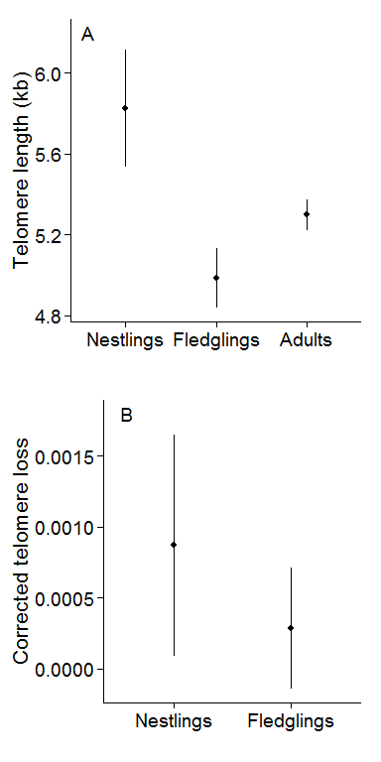

**Figure 2**

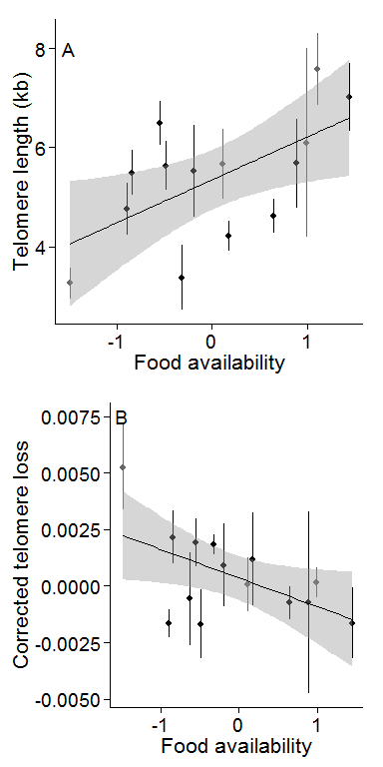**Figure 3**

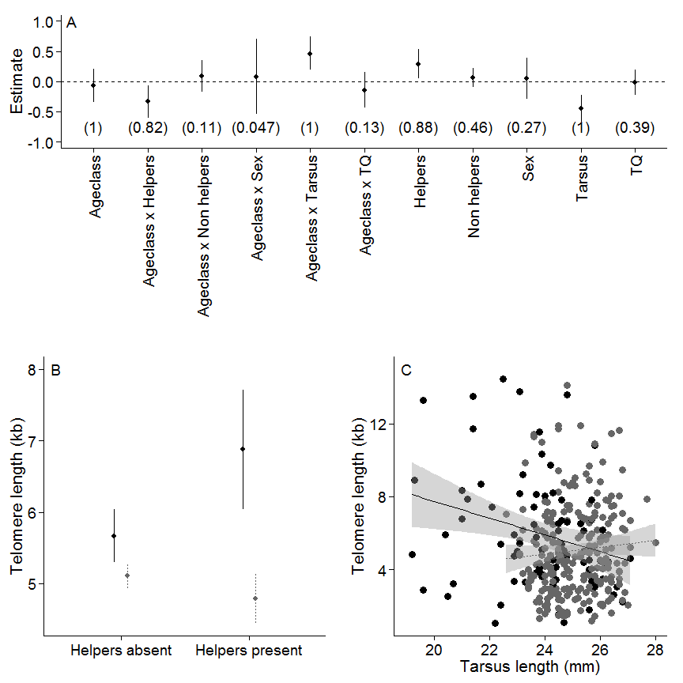

**Figure 4**

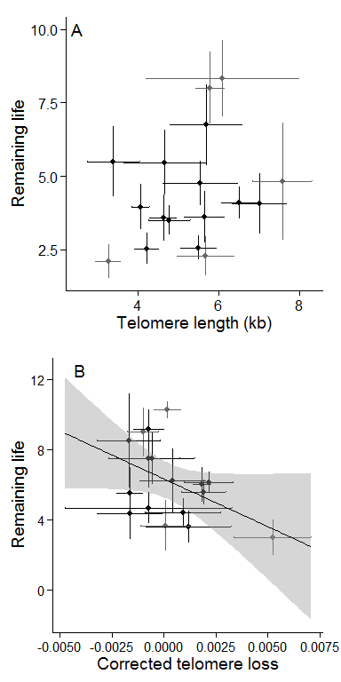**Figure 5**

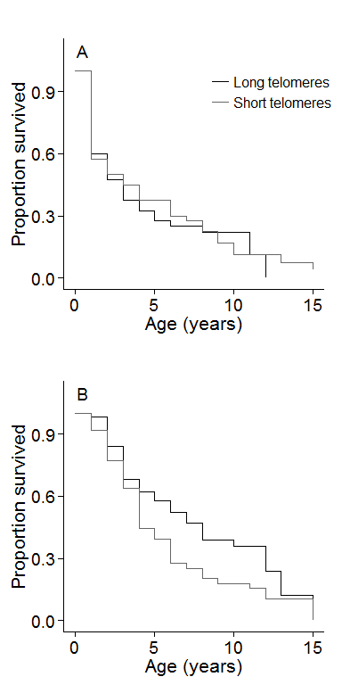

### Supplementary information for Spurgin *et al.* "Telomeres reveal silver spoon effects in a wild population"

**Table S1** Model selection table for analysis of factors affecting early life telomere length in Seychelles warblers. Only models that remained in the top model set for model averaging (AICc $≤$ 6 compared to the top model) are included here. TQ = territory quality.

|  |  |  |  |  |
| --- | --- | --- | --- | --- |
| Model | df | AICc | Delta AICc | Weight |
| Helpers + Tarsus + Ageclass + Ageclass x Helpers + Ageclass x Tarsus | 7 | 663.84 | 0.00 | 0.17 |
| Helpers + Non helpers + Tarsus + Ageclass + Ageclass x Helpers + Ageclass x Tarsus | 8 | 664.63 | 0.79 | 0.11 |
| Helpers + Tarsus + TQ + Ageclass + Ageclass x Helpers + Ageclass x Tarsus | 8 | 665.29 | 1.45 | 0.08 |
| Helpers + Tarsus + Ageclass + Sex + Ageclass x Helpers + Ageclass x Tarsus | 8 | 665.85 | 2.01 | 0.06 |
| Helpers + Non helpers + Tarsus + TQ + Ageclass + Ageclass x Helpers + Ageclass x Tarsus | 9 | 666.08 | 2.24 | 0.05 |
| Helpers + Non helpers + Tarsus + Ageclass + Ageclass x Helpers + Ageclass x Non helpers + Ageclass x Tarsus | 9 | 666.27 | 2.43 | 0.05 |
| Helpers + Tarsus + TQ + Ageclass + Ageclass x Helpers + Ageclass x Tarsus + Ageclass x TQ | 9 | 666.46 | 2.62 | 0.05 |
| Helpers + Non helpers + Tarsus + Ageclass + Sex + Ageclass x Helpers + Ageclass x Tarsus | 9 | 666.58 | 2.74 | 0.04 |
| Tarsus + Ageclass + Ageclass x Tarsus | 5 | 667.29 | 3.45 | 0.03 |
| Helpers + Tarsus + TQ + Ageclass + Sex + Ageclass x Helpers + Ageclass x Tarsus | 9 | 667.33 | 3.49 | 0.03 |
| Helpers + Non helpers + Tarsus + TQ + Ageclass + Ageclass x Helpers + Ageclass x Tarsus + Ageclass x TQ | 10 | 667.44 | 3.60 | 0.03 |
| Non helpers + Tarsus + Ageclass + Ageclass x Tarsus | 6 | 667.66 | 3.82 | 0.02 |
| Helpers + Tarsus + Ageclass + Ageclass x Tarsus | 6 | 667.81 | 3.97 | 0.02 |
| Helpers + Non helpers + Tarsus + TQ + Ageclass + Ageclass x Helpers + Ageclass x Non helpers + Ageclass x Tarsus | 10 | 667.82 | 3.98 | 0.02 |
| Helpers + Tarsus + Ageclass + Sex + Ageclass x Helpers + Ageclass x Tarsus + Fledged:Sex | 9 | 667.94 | 4.10 | 0.02 |
| Helpers + Non helpers + Tarsus + TQ + Ageclass + Sex + Ageclass x Helpers + Ageclass x Tarsus | 10 | 668.07 | 4.23 | 0.02 |
| Helpers + Non helpers + Tarsus + Ageclass + Sex + Ageclass x Helpers + Ageclass x Non helpers + Ageclass x Tarsus | 10 | 668.29 | 4.45 | 0.02 |
| Helpers + Tarsus + TQ + Ageclass + Sex + Ageclass x Helpers + Ageclass x Tarsus + Ageclass x TQ | 10 | 668.44 | 4.60 | 0.02 |
| Helpers + Non helpers + Tarsus + Ageclass + Ageclass x Tarsus | 7 | 668.54 | 4.70 | 0.02 |
| Helpers + Non helpers + Tarsus + Ageclass + Sex + Ageclass x Helpers + Ageclass x Tarsus + Fledged:Sex | 10 | 668.72 | 4.88 | 0.01 |
| Tarsus + TQ + Ageclass + Ageclass x Tarsus | 6 | 668.96 | 5.12 | 0.01 |
| Helpers + Non helpers + Tarsus + TQ + Ageclass + Ageclass x Helpers + Ageclass x Non helpers + Ageclass x Tarsus + Ageclass x TQ | 11 | 669.11 | 5.27 | 0.01 |
| Helpers + Tarsus + TQ + Ageclass + Ageclass x Tarsus | 7 | 669.22 | 5.38 | 0.01 |
| Non helpers + Tarsus + TQ + Ageclass + Ageclass x Tarsus | 7 | 669.29 | 5.45 | 0.01 |
| Tarsus + Ageclass + Sex + Ageclass x Tarsus | 6 | 669.35 | 5.51 | 0.01 |
| Helpers + Non helpers + Tarsus + TQ + Ageclass + Sex + Ageclass x Helpers + Ageclass x Tarsus + Ageclass x TQ | 11 | 669.37 | 5.53 | 0.01 |
| Helpers + Tarsus + TQ + Ageclass + Sex + Ageclass x Helpers + Ageclass x Tarsus + Fledged:Sex | 10 | 669.41 | 5.57 | 0.01 |
| Tarsus + TQ + Ageclass + Ageclass x Tarsus + Ageclass x TQ | 7 | 669.42 | 5.58 | 0.01 |
| Non helpers + Tarsus + Ageclass + Ageclass x Non helpers + Ageclass x Tarsus | 7 | 669.62 | 5.78 | 0.01 |
| Non helpers + Tarsus + Ageclass + Sex + Ageclass x Tarsus | 7 | 669.68 | 5.84 | 0.01 |
| Helpers + Tarsus + TQ + Ageclass + Ageclass x Tarsus + Ageclass x TQ | 8 | 669.69 | 5.85 | 0.01 |